A Major Project Final Report on

**Home Automation**

Submitted in Partial Fulfillment of the Requirements for

The Degree of BEIT

Under Pokhara University

Submitted by:

Puspa Raj Paneru, 181530

Minraj Basnet, 181526

Mukesh Kushwaha, 181527

Prakash Chand Kushwaha, 181529

Under the supervision of

**Assoc Prof. Mr. Satish Kumar Karn**

Date:

13/07/2024

**Department of BEIT**

**NEPAL COLLEGE OF**

**INFORMATION TECHNOLOGY**

Balkumari, Lalitpur, Nepal.

**NEPAL COLLEGE OF**

**INFORMATION TECHNOLOGY**

*(AFFILIATED TO POKHARA UNIVERSITY)*

**DECLARATION**

We, Mukesh Kushwaha, Rajesh Singh, Prakash Chand Kushwaha, Min Raj Basnet, students of BEIT, Nepal college of Information Technology affiliated to Pokhara University, hereby declare that the work undertaken in this major project entitled “Home Automation” is the outcome of our own effort and is correct to the best of our knowledge. This work has been accomplished by obeying the engineering ethics; and it contains neither materials published earlier or written by another person/people nor materials which has been accepted for the award of any other degree or diploma of the university or other institution, except where due acknowledgement has been made in the document.

Mukesh Kushwaha

Date:

Puspa Raj Paneru

Date:

Prakash Chand Kushwaha

Date:

Min Raj Basnet

Date:

Balkumari, Lalitpur, EPC: 1525, GPO Box: 8975, Kathmandu, Nepal.

Tel: 5006270, Fax: 5006360, Email: [info@ncit.edu.np](mailto:info@ncit.edu.np), Website: [www.ncit.edu.np](http://www.ncit.edu.np)

**NEPAL COLLEGE OF**

**INFORMATION TECHNOLOGY**

*(AFFILIATED TO POKHARA UNIVERSITY)*

**SUPERVISOR’S APPROVAL**

This is to certify that the major project entitled “Home Automation” undertaken and demonstrated by Mukesh Kushwaha, Prakash Chand Kushwaha, Min Raj Basnet and Puspa Raj Paneru has been successfully completed under my supervision as a partial fulfillment of the requirements for the degree of BEIT under Pokhara University. I, henceforth, approve this project to be awarded the certificate by the concerned authority.

During supervision, I found students hardworking, skilled and ready to undertaken any professional work related to this field in future.

Supervisor:

Assoc Prof. Mr. Satish Kumar Karn

Date:

Balkumari, Lalitpur, EPC: 1525, GPO Box: 8975, Kathmandu, Nepal.

Tel: 5006270, Fax: 5006360, Email: [info@ncit.edu.np](mailto:info@ncit.edu.np), Website: [www.ncit.edu.np](http://www.ncit.edu.np)

**NEPAL COLLEGE OF**

**INFORMATION TECHNOLOGY**

*(AFFILIATED TO POKHARA UNIVERSITY)*

**EXAMINERS’ ACCEPTANCE**

This is to certify that the major project entitled “Home Automation” presented by Mukesh Kushwaha, Prakash Chand Kushwaha, Min Raj Basnet and Rajesh Singh as a partial fulfillment of the requirements for the degree of BEIT under Pokhara University has been examined and accepted by the following panel of experts. We, henceforth, recommend this project to be awarded by the certificate from the concerned authority.

We extend all the best wishes to the students for their future careers.

Examiner:

Mr. Nirdosh Adhikary

Date:

Examiner:

Mr. Examiner name

Date:

Balkumari, Lalitpur, EPC: 1525, GPO Box: 8975, Kathmandu, Nepal.

Tel: 5006270, Fax: 5006360, Email: [info@ncit.edu.np](mailto:info@ncit.edu.np), Website: [www.ncit.edu.np](http://www.ncit.edu.np)

**NEPAL COLLEGE OF**

**INFORMATION TECHNOLOGY**

*(AFFILIATED TO POKHARA UNIVERSITY)*

**CERTIFICATE**

Following the supervisor’s Approval and Examiners’ Acceptance, the major project entitled “Home Automation” submitted by Mukesh Kushwaha, Min Raj Basnet, Prakash Chand Kushwaha, and Puspa Raj Paneru as a partial fulfillment of the requirements for the degree of BEIT under Pokhara University, has been officially awarded by this certificate.

I wish the students all the best for their future endeavours.

Mr. Madan Kadariya

Head, Department of BEIT

Date:

Balkumari, Lalitpur, EPC: 1525, GPO Box: 8975, Kathmandu, Nepal.

Tel: 5006270, Fax: 5006360, Email: [info@ncit.edu.np](mailto:info@ncit.edu.np), Website: [www.ncit.edu.np](http://www.ncit.edu.np)

# **Acknowledgment**

We would like to express my deepest gratitude and appreciation to the individuals who have contributed to the successful completion of my Home Automation System project. Their guidance, support, and encouragement have been invaluable throughout this endeavor.

First and foremost, we would like to thank the Head of the Department (HOD) Mr. Madan Kadariya of BEIT for their unwavering support and guidance. Their expertise and insightful suggestions have been instrumental in shaping the direction of my project and enhancing its overall quality. We are also indebted to my supervisor Mr. Satish Karn, whose wisdom and mentorship have been truly invaluable. Their constant guidance, constructive feedback, and patience have greatly contributed to the completion of this project. We are grateful for their dedication and belief in my abilities.

Furthermore, we would like to extend my heartfelt appreciation to our family members for their unending love, encouragement, and understanding. Their unwavering support throughout this project has been a constant source of motivation for us. We would also like to acknowledge the support and friendship of our friends. Their encouragement, brainstorming sessions, and willingness to lend a helping hand have been crucial in overcoming challenges and keeping us motivated throughout the project.

Once again, we extend our heartfelt thanks to all those mentioned above for their contributions to our Home Automation System project. Without their support, this project would not have been possible.

# **Abstract**

Home Automation is a system based on the Internet of Things (IoT). It is a technology driven solution for managing and controlling various aspects of a home. This system provides an easy and simple way to monitor and control home appliances remotely. The proposed home automation system also provides safety and security to homes using different sensors.

Our system comprises hardware and software technology. It includes hardware components like esp32, mq-2 sensor, ultrasonic sensor, flame sensor and software components like app and aws services. Esp32 microcontroller is responsible for controlling all the appliances and sending all the sensor data to aws core IoT. We have built an application using react native technology which provides an interface to users to control home appliances. We use different aws services like aws amplify, aws API gateway, amazon DynamoDB in the backend. These services allow communication between application and esp32 microcontrollers which then allows us to control different home appliances.

Thus, it is a comprehensive and efficient solution for homes. This system will provide a user friendly interface that allows them to monitor and control home appliances remotely. It simplifies and enhance various aspects of home management and control through the integration of technology

Keywords: Home Automation, IoT, home appliances, AWS, Esp32.

# **Table of Contents**

**Acknowledgment** 2

**Abstract** 3

**Table of Contents** 4

**List of Figures** 5

**Introduction** 6

Problem Statement 7

Project Objectives 8

Significance of the study 9

**Literature Review** 10

**Methodology** 11

**Conclusion** 22

**Further Works/ Recommendations** 23

**Budget and Estimation** 24

References 25

# **List of Figures**

Figure 1: ESP-32 microcontroller 11

Figure 2: 4-Channel Relay Module 12

Figure 3: MQ-2 Sensor 13

Figure 4: 3-layer IOT Architecture 16

Figure 5: Publisher Subscriber Model 17

Figure 6: Use Case Diagram 18

Figure 7: Sequence Diagram 19

Figure 8: Work flow diagram of home automation system 20

Figure 9: Circuit Diagram 21

# **Introduction**

The advancement of automation technology has greatly improved human life by making it easier, more comfortable, and less demanding across various sectors. Smart home automation systems enable users to control and monitor their home appliances from anywhere in the world using a smart mobile device or laptop. Automation systems are now preferred over manual systems, and the Internet of Things (IoT) plays a crucial role in connecting and managing home appliances through the internet. Smart home automation systems utilize IoT technology, allowing interconnected sensors and devices to communicate independently with minimal human interaction. With such a system, tasks like monitoring humidity, lights, air flow, heat, doors, fans, and more in and around living units become easier, while also offering desirable states such as security, safety, comfortability, convenience, peace of mind, and reliability [1].

The Internet of Things (IoT) is a network of interconnected electronic devices, sensors, and controllers that communicate with each other over the internet to perform user-demanded tasks. It has enabled the development of various IoT applications in areas like smart homes, cities, healthcare, and transportation. The IoT allows users to connect and monitor electronic devices via the internet, adjusting their parameters remotely. By collecting, storing, and analyzing data efficiently from actuators and sensors, IoT systems provide valuable information to smart devices like personal computers or mobile phones. Security is a significant concern in home automation systems, where intrusion prevention, gas leakage, fire safety, and theft prevention are crucial requirements. Additionally, smart home automation systems aim to reduce energy wastage, making a positive contribution to energy conservation [2].

## Problem Statement

The problem with the current home automation systems available in the market firstly, is that they lack comprehensive solutions for managing home appliances, detecting gas leaks, and providing security. This creates challenges for users who may have to purchase multiple systems to manage all their home appliances which can be more expensive. Current home automations systems often have limited features and make it difficult to control all the appliances and monitor their safety.

Secondly, there is a lack of modularity between the power supply, microcontroller, and switches, which introduces inefficiency and cost concerns. In the current setup, if any of these components are damaged or malfunctioning, users are compelled to replace the entire board, resulting in unnecessary expenses and resource wastage. This lack of modularity not only limits the flexibility and scalability of the home automation system but also makes maintenance and repairs a cumbersome process. Users should have the ability to replace or upgrade individual components as needed, ensuring a cost-effective and efficient solution for home automation. Also there is lack of synchronization between manual switches and remote switches leads to conflicts in controlling electrical appliances.

Overall, the current home automation system suffers from the lack of synchronization between manual and remote switches, as well as the absence of modularity between power supplies, microcontroller, and switches. Addressing these issues is crucial to enhance user experience, reduce energy wastage, and improve the flexibility and affordability of home automation systems.

## Project Objectives

* To allow homeowners to remotely control their home appliances and systems from a central interface.
* To provide homeowners with greater convenience, safety, security and energy efficiency.

## Significance of the study

The proposed Home Automation system is significant for several reasons. Here are some of the significant aspects of the study:

* It provides a more convenient and comfortable lifestyle for homeowners.
* It can control appliances remotely and help users to save energy.
* Improve safety as gas sensors can detect gas leaks in the home and notify users of potential danger and enable users to take necessary action.
* Designed to be affordable and accessible allowing more people to benefit from this technology.

# **Literature Review**

Home automation systems are becoming increasingly popular and for good reason. These systems offer homeowners the ability to control and monitor various appliances and systems in their homes with ease, improving convenience, energy efficiency, security, and safety. This literature review will discuss the technologies and concepts that underpin home automation, including IoT technology, gas sensors, and the esp32 and aws services, and will explore the related work that has been done in these areas. The methodology used in the implementation of a home automation project will also be discussed, along with the results of the project [3].

Home automation is made possible by IoT technology, which allows devices to be connected and communicate with each other over the internet. This technology enables homeowners to control and monitor various appliances and systems in their homes remotely. Gas sensors are also an important part of home automation, as they can detect gas leaks and alert homeowners to potential dangers. Finally, the Arduino and Blynk platforms are commonly used in home automation projects, as they offer a range of features and benefits [4].

Here are some examples of home automation projects that are currently available on the market:

* Amazon Echo: The Amazon Echo is a popular smart speaker that includes a voice assistant called Alexa. Users can interact with the device using voice commands to control various aspects of their homes, such as turning on lights, adjusting thermostats, and playing music [5].
* Philips Hue Smart Lighting: Philips Hue is a range of smart lighting products that allow users to control the lighting in their homes using a smartphone app. Users can adjust the brightness and color of the lights, and even set schedules for when the lights should turn on and off [6].
* August Smart Lock: The August Smart Lock is a device that can be attached to an existing deadbolt lock, allowing users to control the lock using a smartphone app. The device can also be programmed to automatically unlock the door when the user approaches [7].

The gap between the available automation system and our system is lack of synchronization of manual switch and remote switch. When we do on or off manually, their status is not reflected on the application interface. Our home automation system will address this issues.

# **Methodology**

The home automation system will be developed using a combination of hardware and software components. The system will be based on the Internet of Things (IoT) technology, which allows for the integration of various devices and sensors. The system will consist of a central hub, which will be connected to the internet and to the various home appliances and systems. The central hub will be controlled via a mobile application, which will provide homeowners with an easy-to-use interface for controlling their home appliances and systems.

The hardware components of the system will include ESP32 microcontroller for automation and controlling devices. The sensors such as MQ-2 is used to detect LPG gas. The controllers will be used to communicate with the sensors and to control the various home appliances and systems. The actuators will be used to control the various home appliances, such as the lighting, heating, and cooling systems.

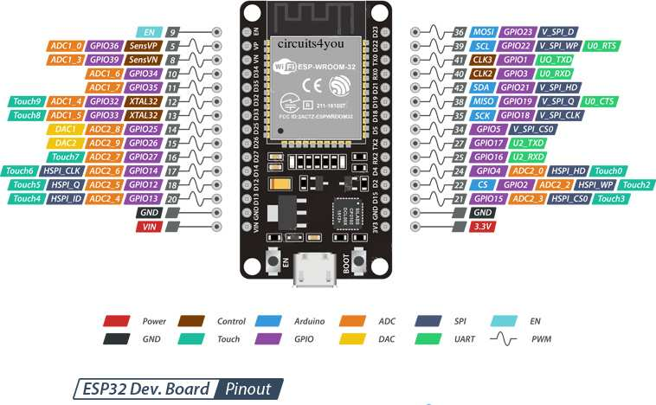

Figure 1: ESP-32 microcontroller

The ESP32 is a versatile microcontroller and system-on-a-chip (SoC) that is widely used in the field of embedded systems and IoT (Internet of Things) development. The ESP32 features a powerful dual-core processor, which enables multitasking and efficient handling of complex tasks. The cores can be independently controlled and programmed, offering flexibility in application development. The ESP32 is designed to be energy-efficient, allowing it to operate on low power. It includes features like fine-grained power management, sleep modes, and wake up capabilities, making it suitable for battery-powered and energy-conscious applications. We have used ESP32 to subscribe and publish to Aws IoT core. It is essentially acting as an IoT device within the MQTT communication model. The light,fan and gas sensor can also be considered as IoT devices or endpoints that are publishing and subscribing to the topics on ESP32, which in turn communicates with Aws IoT Core. Here the key point is that the ESP32 acts as a gateway or intermediary between the IoT devices(light, fan, gas sensor etc.) and the message broker(Aws IoT core).

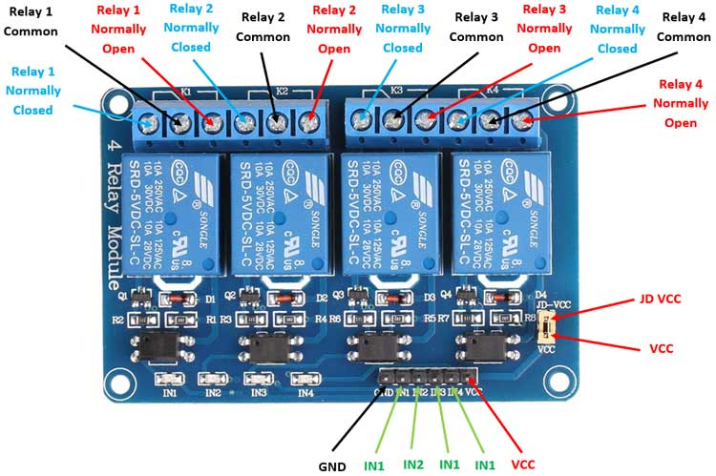

Figure 2: 4-Channel Relay Module

A relay is an electrically operated switch that uses an electromagnet to mechanically control the opening and closing of its contacts. It is commonly used in electrical and electronic circuits to control the flow of current to various devices or components. The main purpose of a relay is to allow a low-power circuit to control a high-power circuit, providing isolation and protection between the two circuits. A relay consists of three main components: an electromagnet, a set of movable contacts, and a spring. The contacts are typically made of conductive materials such as copper or silver.

Working of relay module:

When a current flows through the coil of wire around the electromagnet, it creates a magnetic field. This magnetic field attracts a metal armature connected to the movable contacts. The movable contacts are connected to the high-power circuit, while the control circuit is connected to the coil of the electromagnet. When the electromagnet is energized, it pulls the armature towards it, causing the contacts to close. When the electromagnet is de-energized, the spring pulls the armature back, opening the contacts. Relays provide isolation between the control circuit and the high-power circuit. This means that the control circuit, which might operate at a low voltage and current, is electrically isolated from the high-power circuit, which might operate at a higher voltage and current. This isolation protects the control circuit from potential damage.

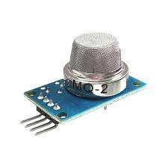

Figure 3: MQ-2 Sensor

The MQ-2 sensor is a gas sensor widely used in various applications, including home automation systems.It is specifically designed to detect and measure the concentration of flammable gases such as LPG, propane, methane, and hydrogen.The MQ-2 sensor operates based on the principle of metal oxide semiconductor (MOS) technology, where the presence of target gases changes the conductivity of the sensor.It is highly sensitive and can detect gas concentrations in the range of several parts per million (ppm) to tens of thousands of parts per million (ppm).The MQ-2 sensor is commonly integrated into home automation systems to provide early detection and alert homeowners in case of gas leaks, ensuring safety and preventing potential hazards.

The software components of the system will include the mobile interface, which will be used to control the central hub i.e. microcontroller, and the backend systemi.e aws cloud services, which will be used to manage the various devices and sensors. We have used following cloud services in the backend:

AWS IoT core:

It is a managed cloud service provided by Amazon Web Services (AWS) that enables secure and scalable communication between IoT devices and the cloud. It provides a set of powerful features and functionalities to manage, connect, and interact with IoT devices.

We have used AWS IoT Core as an infrastructure for connecting IoTdevices, including the ESP32, to the cloud and we have used MQTT communication protocol for it.We have used it as a message broker as it follows the publish-subscribe messaging pattern, which is fundamental characteristics of a broker. In this pattern, devices (publishers) send messages to specific topics, and other devices or applications (subscriber) can subscribe to those received messages. AWS IoT Core acts as the central communication hub, receiving messages published by devices and routing them to the appropriate subscribers. It handles the message distribution, topic management, and scalability aspects, which are core responsibilities of a message broker.

We have used a powerful Rules Engines feature of AWS IoT Core to enable message transformation, filtering and routing based on conditions and criteria. By using Rules Engines, we can define rules to process incoming messages and perform actions based on the content, sender or other attributes of the message.We have used the IoT Core to seamlessly integrate with other AWS services, to utilize the full capabilities of the AWS ecosystem. For example we have used AWS Lambda functions for server less computing.

GraphQL:

It is a query language and runtime that allows clients to request and receive precisely the data they need from an API. It provides a more efficient and flexible alternative to traditional REST APIs. AWS offers services and tools that support GraphQL-based development and we have used some of them which is mentioned below.

AWS Lambda:

AWS Lambda is a server less compute service that allows you to run code without provisioning or managing servers. While not specifically designed for GraphQL, Lambda can be used in conjunction with other AWS services, such as API Gateway, to build GraphQL APIs. You can write resolver functions in your preferred programming language to handle GraphQL operations and interact with data sources or other services. In our project whenever the new data is updated in the database (DynamoDB), the lambda function is triggered and performs the necessary operation.

AWS DynamoDB:

We have stored our data provided by the IoT devices in the DynamoDB.Amazon DyanmoDB is a fully managed NoSQL database service provided by AWS. It is designed to provide fast and scalable storage for applications that require low-latency access to data. DynamoDB is a key-value store that offers seamless scalability and automatic data replication across multiple AWS Availability Zones. It provides high performance at any scale by distributing data across multiple partitions to handle large volumes of read and write operations. DynamoDB supports flexible data models, allowing you to store structured, semi-structured, or unstructured data. We have integrated DynamoDB with GraphQL through AppSync to provide seamless access to our DynamoDB tables from GraphQL API.

AWS Cognito:

It is a fully managed identity and access management service that allows you to add user sign-up, sign-in, and authentication to your applications. It provides a simple and secure way to handle user management, authentication, and authorization in your application.

React-Native:

It is an open-source framework developed by Facebook for building mobile applications using JavaScript. It allows developers to create native mobile apps for iOS and Android platforms using the same codebase. React Native uses JavaScript, a widely-used programming language, and leverages the power of React, a popular JavaScript library for building user interfaces. Developers can utilize their existing knowledge of JavaScript and React to develop a mobile app. We have used this framework to create our own app that provides the UI of our system including the components like buttons, to turn ON/OFF the light bulb, slider to turn ON/OFF and control the speed of the fan. It also contain gauge to monitor the gas level of the home.

The app will follow the client-service architecture. The client-side will communicate with Aws services. The Aws IoT core will handle device management, secure communication and data exchange.

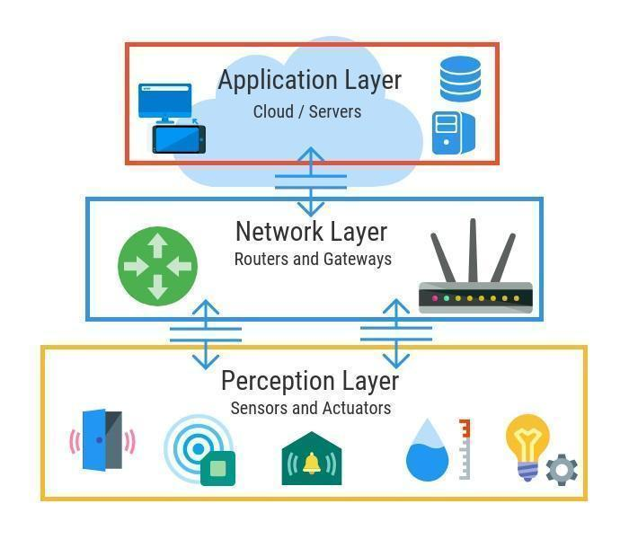

Figure 4: 3-layer IOT Architecture

1. **Perception Layer:**

This perception layer is the IoT architecture’s physical layer. In these sensors and embedded systems are used mainly. These collect large amounts of data based on the requirements. This also includes edge devices, sensors, and actuators that communicate with the surroundings.

1. **Network Layer:**

The data obtained by these devices must be distributed and stored. This is the responsibility of the network layer. It binds these intelligent objects to other intelligent/ smart objects. It is also in charge of data transfer. The network layer is in-charge of linking smart objects, network devices, and servers. It is also used to distribute and analyze sensor data.

1. **Application Layer:**

The user communicates with this application layer. It is in-charge of providing the customer with software resources. Example: in smart home application, where users press a button in the app to switch on a coffee machine, for example. The application layer is in-charge of providing the customer with application-specific resources. It specifies different uses for the IoT, such as smart houses, smart cities, and smart health.

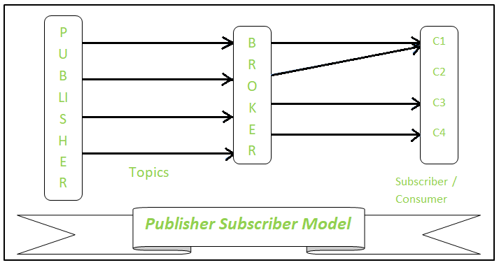

Figure 5: Publisher Subscriber Model

Our System is based on Publisher Subscriber Model. For this we have used MQTT protocol. MQTT (Message Queuing Telemetry Transport) is a lightweight publish-subscribe messaging protocol designed for efficient communication between devices with limited bandwidth or unreliable networks. MQTT follows the Publish-subscribe messaging pattern where the devices publish messages to specific topics and other devices can subscribe to those topics to receive the messages. We have used this protocol as a communication model for our project.

Figure 6: Use Case Diagram

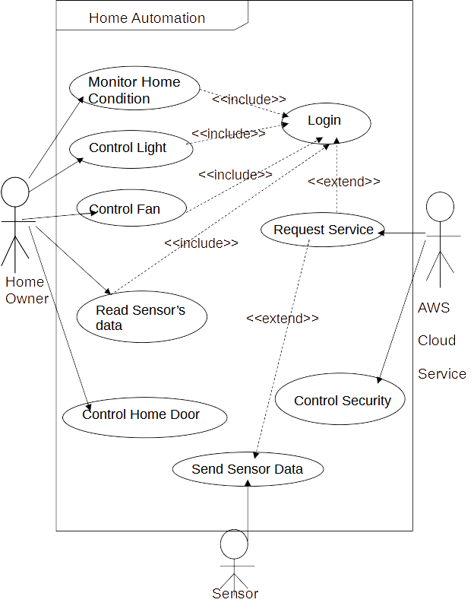

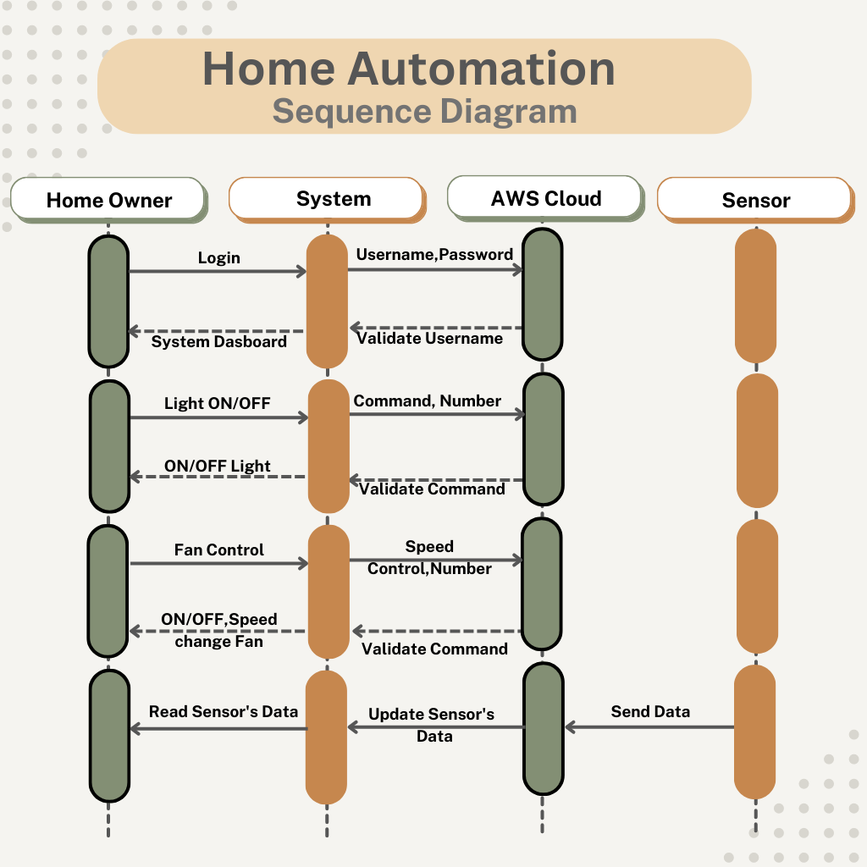

Figure 7: Sequence Diagram

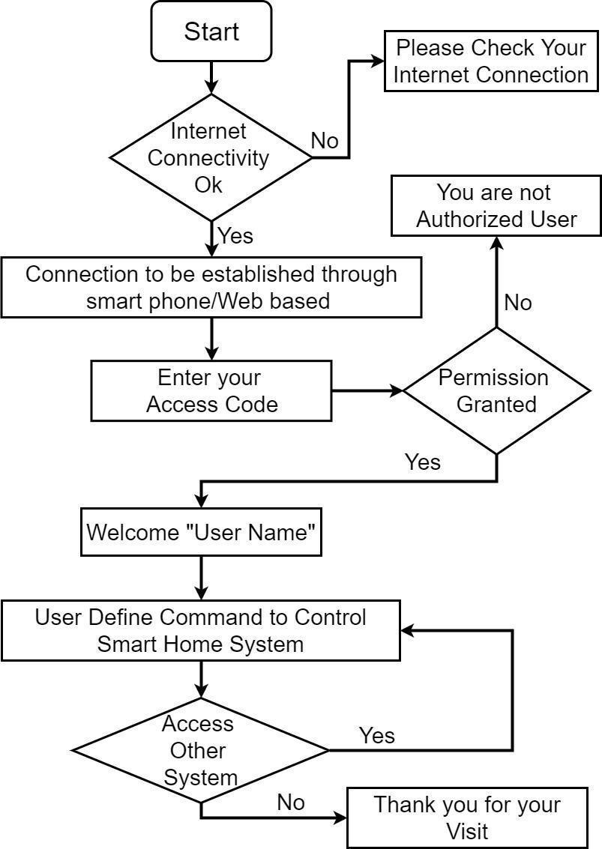

Figure 8: Work flow diagram of home automation system

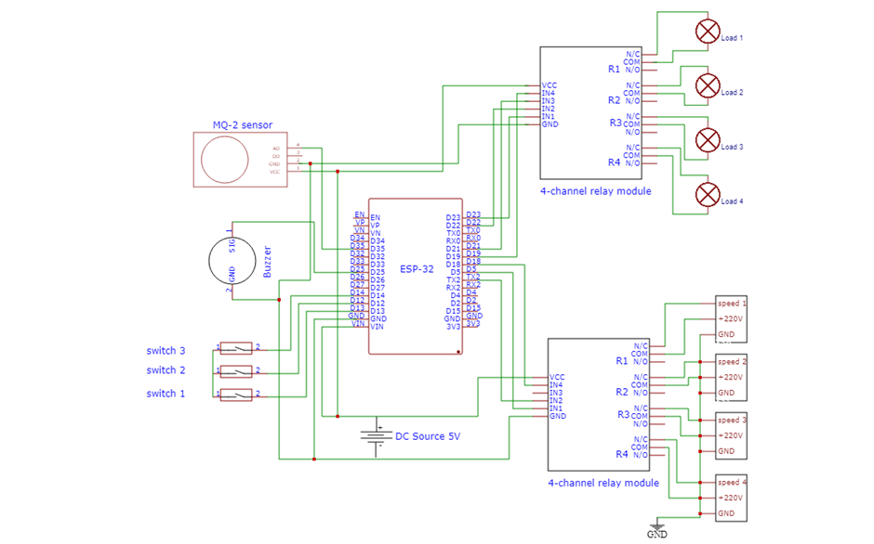

Figure 9: Circuit Diagram

# **Conclusion**

In conclusion, our home automation system project aimed to simplify and enhance various aspects of home management and control through the integration of technology. We successfully achieved our objectives of remotely controlling home appliances and providing homeowners with greater convenience, security and energy efficiency with a user friendly mobile interface.

Throughout the implementation and testing phase, we utilized a comprehensive methodology that integrated various components and systems. These included hardware like mq-2 sensor, flame sensor, ultrasonic sensor and a central hub, esp32 microcontroller. By connecting these devices through robust network infrastructure i.e. amazon web services and building mobile applications using react-native technology, we created a seamless home automation system.

Thus, our home automation system project has demonstrated the immense potential of technology to transform traditional homes into smart and efficient living spaces. By achieving our goal of remotely control of home appliances, safety and security of home, we have laid the foundation for future advancements in the field of home automation.

# **Further Works/ Recommendations**

As technology is evolving rapidly, there is always room for further improvements and innovation. Our future works includes following things

* We will divide our system in three modules i.e. power supply module, microcontroller module and switch module.
* We will integrate artificial intelligence in our system to give more personalized and efficient automation.
* We will integrate voice and gesture control in our system to provide a hand free experience.
* We will integrate advanced biometric authentication technology and intrusion detection systems to enhance the overall security of the home.

# **Budget and Estimation**

|  |  |  |
| --- | --- | --- |
| Components | Quantity | Amount (in Rs.) |
| ESP32 | 1 | 945 |
| Gas Sensor ( MQ-2) | 1 | 300 |
| Flame Sensor | 1 | 345 |
| UltraSonic Sensor | 1 | 200 |
| 4 Channel Relay Module | 2 | 980 |
| Buzzer | 1 | 100 |
| Jumper Cables ( Male to Male | 20 | 100 |
| Jumper Cable ( Male to Female | 20 | 100 |

# **References**

|  |  |
| --- | --- |
| [1] | A. S. Abdulraheem, A. A. Salih, A. I. Abdulla and A. Mohammed, "Home Automation System based on IoT," *Technology Reports of Kansai University,* vol. 62, p. 2453, 2020. |
| [2] | Chaurasia, T. Jain and P. Kumar, Enhanced Smart Home Automation System based on Internet of Things, 2019, pp. 709-713. |
| [3] | S. Dey, A. Roy and S. Das, "https://ieeexplore.ieee.org/," 2016. [Online]. Available: https://ieeexplore.ieee.org/abstract/document/7777826. [Accessed June 2023]. |
| [4] | H. K. Singh, S. Verma, S. Pal and K. Pandey, "https://ieeexplore.ieee.org/," August 2019. [Online]. Available: https://ieeexplore.ieee.org/abstract/document/8844945. [Accessed June 2023]. |
| [5] | C. Jackson and A. Angela, "A study of security and privacy issues associated with the Amazon Echo," *International Journal of Internet of Things and Cyber-Assurance,* vol. 1, pp. 91-100, 5 March 2018. |
| [6] | S. Hilbolling, H. Berends, F. Deken and P. Tuertscher, "Sustaining Complement Quality for Digital Product Platforms: A Case Study of the Philips Hue Ecosystem," *Journal of Product Management,* vol. 38, no. 1, pp. 21-48, 2020. |
| [7] | M. Ye, N. Jiang, H. Yang and Q. Yan, "https://ieeexplore.ieee.org/," 2017. [Online]. Available: https://ieeexplore.ieee.org/abstract/document/8116427. [Accessed June 2023]. |